
RAMAIAH
INSTITUTE OF TECHNOLOGY
USN | 1 | M | S

(Autonomous Institute, Affiliated to VTU)
Bangalore – 560 054

SUPPLEMENTARY SEMESTER EXAMINATIONS – AUGUST 2017

Course & Branch | : | B.E : Information Science and Engineering | Semester | : | IV
Subject | : | Design and Analysis of Algorithms | Max. Marks | : | 100
Subject Code | : | IS414 | Duration | : | 3 Hrs

Instructions to the Candidates:
- Answer one full question from each unit.

 |  | UNIT - I
1. | a) | Discuss the general plan for analyzing the time efficiency of Recursive algorithms. Apply the above plan to compute the time efficiency of Tower of Hanoi problem. | CO1 | (10)
 | b) | Define the terms O, θ and Ω notations giving suitable example for each. | CO1 | (10)
2. | a) | With a neat flow diagram, discuss the fundamental steps in the design and analysis of algorithms. | CO1 | (10)
 | b) | Discuss the basic efficiency classes in detail. | CO1 | (10)
 |  | UNIT - II
3. | a) | Design an algorithm to sort the elements using Quick Sort using divide and conquer technique and derive the worst case efficiency of the same. | CO1 | (10)
 | b) | Write Horspool’s Algorithm. Apply the same to search for the pattern LEADER in the text JIMY_RAN_HAILED_THE_LEADER_TO_STOP. | CO1 | (10)
4. | a) | Define Brute force algorithm technique. Design an algorithm to sort the elements using selection sort. Derive its time efficiency by setting up summation expression. | CO1 | (10)
 | b) | Discuss the general plan for working of divide and conquer technique. Apply the same to sort the given list of elements using Merge sort.  89, 45, 68, 90, 29, 34, 17. | CO1 | (10)
 |  | UNIT - III
5. | a) | Define greedy technique. Write Prim’s algorithm and find out the minimum spanning tree for the graph given below using the same.  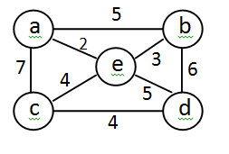 | CO1 | (10)
 | b) | Write Dijkstra's algorithm and apply the same to find single source shortest path problem for the graph taking vertex 'A' as source.  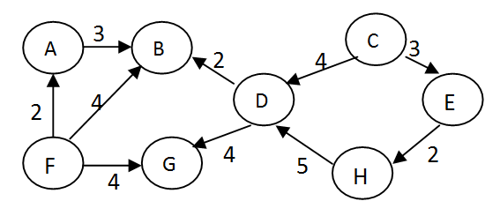 | CO1 | (10)
6. | a) | Write Floyds algorithm and apply the same to compute all pair shortest paths for the following graph.  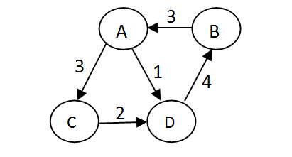 | CO1 | (10)
 | b) | Write an algorithm to solve the knapsack problem using memory functions. Use the same to solve the following knapsack problem with capacity W=6. | CO1 | (10)
  Item | Weight | Value
  1 | 3 | 12
  2 | 2 | 20
  3 | 1 | 15
  4 | 4 | 40
  5 | 5 | 50
 |  | UNIT- IV
7. | a) | Discuss the variations of decrease-and –conquer design technique. Apply DFS based algorithm to solve the topological sorting problem for the given graph.  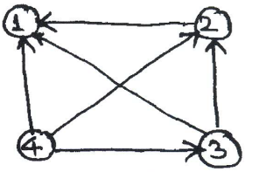 | CO2 | (10)
 | b) | Explain the differences between DFS and BFS. | CO1 | (05)
 | c) | Find J(40)-the solution for Josephus problem for n=40 | CO2 | (05)
8. | a) | Construct AVL tree for the set of elements 5, 6, 8, 3, 2, 4, 7. | CO2 | (08)
 | b) | Analyze the worst-case efficiency of search operation in 2-3 tree. | CO1 | (07)
 | c) | What is transform and conquer? Discuss the three variations of transform and conquer technique. | CO1 | (05)
 |  | UNIT - V
9. | a) | Develop a pseudocode to construct a heap by bottom-up method. Trace the same for the list 2,9,7,6,5,8. | CO1 | (10)
 | b) | State four problems for which no polynomial-time algorithm has been found nor the impossibility of such an algorithm has been found. | CO3 | (04)
 | c) | Differentiate between back tracking and branch-and-bound algorithm. | CO1 | (06)
10. | a) | Define the following:  (i) P Problem (ii) Non deterministic algorithm (iii) NP Problem (iv) Polynomially reducible problem (v) NP-complete problem. | CO3 | (10)
 | b) | What is the central principle of back tracking? Taking n-queens problem as an example, explain the solution process (State space tree construction). | CO1 | (10)

****************

